

CHAPTER NOTICE

**2025 Mid-Michigan Chapter Golf Outing  
Proceeds to benefit the Michigan Credit Union Foundation.**



Wednesday, July 30, 2025 • 10:00 a.m. – Shotgun Start

# Maple Leaf Golf Course

158 N. Mackinaw Road, Linwood, MI 48634   
(North of Bay City - East of I-75) Phone: (989) 697-3531

**Cost: $80.00 per Golfer**

Includes 18 holes of golf with cart, hot dog lunch “at the turn,”   
dinner after golf (cash bar) and prizes!

**Mulligans: $5 contribution to MCULLAF**

(Contributions to MCULLAF or MCULAF are not considered charitable contributions or business expense for income tax purposes. Contributions are voluntary and there will be no reprisal for not contributing.)

**Wanted**: Donations for door prizes and skill prizes. If you can donate, please indicate on the attached confirmation slip and bring the donation with you on July 30, 2025.

## SPOGL017Reservation Deadline is Wednesday, July 16, 2025

Please mail this form and your draft/checks payable to **Wildfire Credit Union** to:

Wildfire Credit Union

Attn: Brian Pennington

P.O. Box 3285 • Saginaw, MI 48605-3285

Contact Person:_________________________________ Phone: _______________________ Email:__________________________________

CU or Company :__________________________________________________________________________________________________________

Address: _______________________________________________ City: _______________________________ Zip: ________________________

Number of golfers: _______________ x $80 = $ ________________________

Names of golfers in foursome: (All welcome! We will match you with someone, if unable to get a foursome).

1_________________________________________________ 3__________________________________________________________

2_________________________________________________ 4___________________________________________________________

**Yes, we wish to donate a door prize.** Item: _______________________________________________________________________

Contact Person __________________________________________________ Phone ________________________________________________

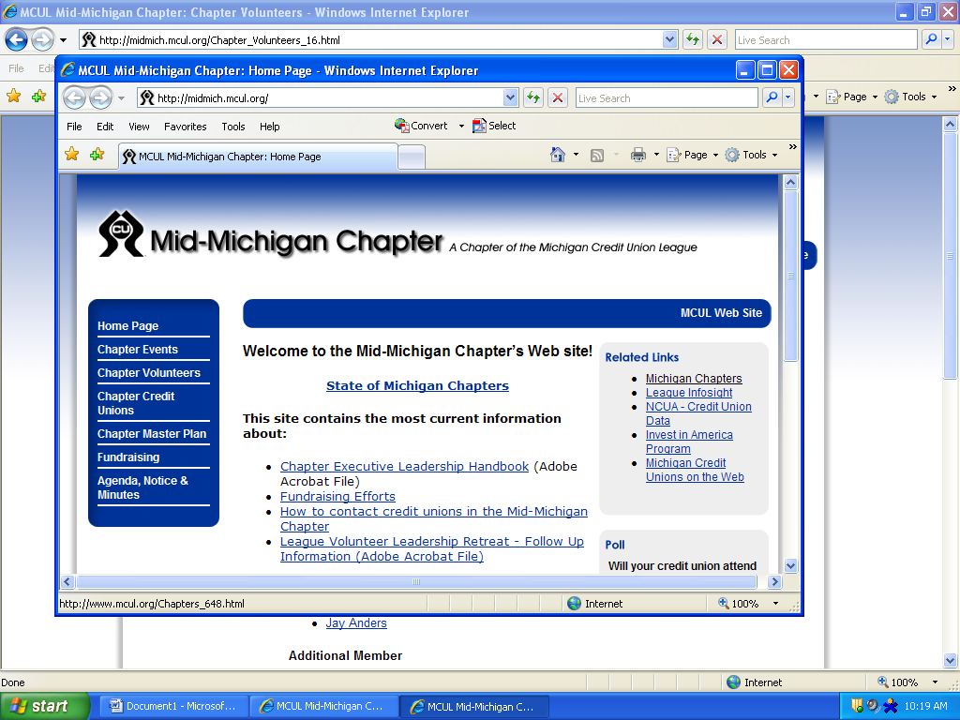

**2025 Mid-Michigan Chapter Golf Outing**

**Sponsorship Opportunities**

The Mid-Michigan Chapter of Credit Union’s Annual Golf Outing is coming soon. As this is a cooperative effort, we would appreciate your consideration in becoming one of our sponsors.

The outing is on Wednesday, July 30, 2025 at the Maple Leaf Golf Course at 158 N. Mackinaw Road, Linwood, MI 48634 (North of Bay City; East of I-75).

A portion of the proceeds in 2025 will support the Michigan Credit Union Foundation. The Foundation provides educational scholarships and grants for Michigan credit unions and chapters for the purposes of supporting credit union member services, community outreach, employee educational development, and strengthening the Michigan Credit Union Movement.

Donations will also support multiply food pantries in the Great Lakes Bay Region.

**Sponsorship Opportunities:**

Hole Sponsor - $150.00 (per hole) Contest Sponsors - $200.00

Sponsorships must be *prepaid* and received by July 19th, to receive signage at the outing. Please provide the information below, and mail a check payable to **Wildfire Credit Union** to the following address:

**Wildfire Credit Union**

Attn: Brian Pennington

P.O. Box 3285

Saginaw, MI 48605-3285

*Sponsorship Information:*

Company/CU Name: _______________________________________________________________________________________

Contact Person: _____________________________________________ Best time to call: ____________________________

Phone Number: _____________________________________________ Email: ________________________________________

Address: _____________________________________________________________________________________________________

Please send your logo (TIFF or PNG preferred format) to Brian at [bpennington@wildfirecu.org](mailto:bpennington@wildfirecu.org).