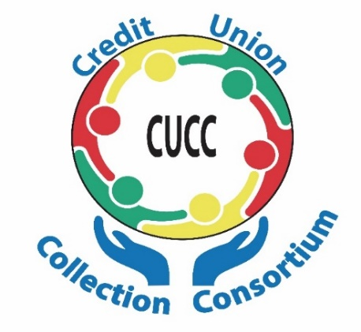
REGISTER NOW FOR COLLECTOR TRAINING SCHOOL MAY 7, 2019
Presented by your Credit Union Collection Consortium
The Credit Union Collection Consortium, a networking and education group in its 26th year, is proud to announce its annual Collector Training School to be held on Tuesday May 7, 2019, at the beautiful Michigan State University Management Education Center located at 811 W. Square Lake Road in Troy.
Renowned national speaker Steve Kreitlow of Credit Union Recovery will be teaching a one-day course on optimizing your credit union’s collection activities. Steve specializes in debt-collection skills and will show you how to improve your delinquency and loan loss results. He trains new and experienced collectors in a lively and focused atmosphere.
Tuition of $110 covers all materials, including breakfast and lunch, a networking roster of attendees and fabulous door prizes-- an incredible value thanks to our generous sponsors. This is a must-attend event for all collection, loss prevention, and risk management professionals. Registration begins at 8:00 a.m., and the event runs from 8:30 a.m. to 4:00 p.m. For out-of-towners, several hotels are available in the area. Contact Peggy Dombrowski at pdombrowski@genisyscu.org for more information.
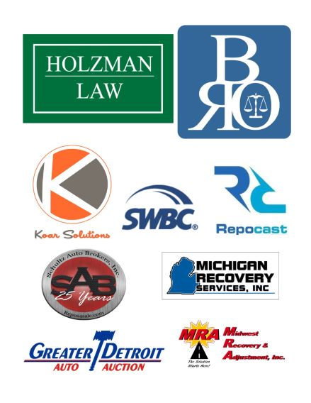

Steve Kreitlow
Continuing Education Facilitator, CU Recovery

COLLECTOR TRAINING SCHOOL REGISTRATION FORM
Name________________________________________ Credit Union_____________________________
Email___________________________________________ Phone______________________________
Address____________________________________________ Job Title___________________________
Please enclose $110 event fee with this registration form payable to: “Credit Union Collection Consortium”, c/o Genisys Credit Union, 2100 Executive Hills Drive, Auburn Hills, MI 48236, attention: Peggy Dombrowski

