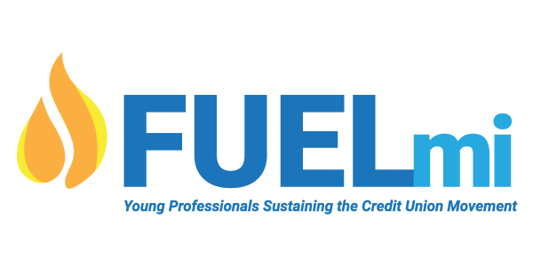

FUEL MI 2022 | (Fueling, Uplifting, Educating Leaders)
Young Professionals Sustaining the CU Movement
FUEL MI, a Young Professionals Networking Group, this group was formed with support from the Michigan Credit Union Foundation (MCUF) to encourage lifelong involvement within the credit union movement now and into the future.

FUEL MI aims to expand, support, and provide opportunities for networking, collaboration, leadership development, and cooperative community outreach for emerging credit union professionals.

The FUEL MI Young Professionals Networking Group is searching for driven and dedicated young professionals who are passionate about sustaining the credit union movement to join the statewide program. Group members will meet in person and virtually quarterly. FUELmi will be implementing methods for participants to connect, interact and learn about the credit union industry and movement, as well as actively participate in community outreach initiatives throughout Michigan.

The group will focus on expanding opportunities for young professionals in the credit unions in these areas:
- Networking / Chapter Involvement
- Professional Development / Advocacy Awareness
- Charitable Outreach / Credit Union Social Mission Initiatives

To Join FUEL MI – Complete and submit the following participation form.

Questions? – FUEL MI Contacts:

- FUEL MI Group Leaders:
  - Casey Clark, cclark@adviacu.org – 844-238-4228 ext. 1950
  - Kyle Gurzynski, kgurzynski@safeharborcu.org - 231-233-8715

- Beth Troost, Michigan Credit Union Foundation Beth.Troost@mcul.org 734-793-3453

FUEL Michigan
Young Professionals Networking Group Application Form
FUEL MI is a statewide program which encourages life-long involvement with credit unions. The main goal for the group is to expand support and provide opportunities for networking, collaboration, and developing credit union leaders. The group is encouraged to determine and implement additional ways for participants to connect, interact and learn about the credit union industry and movement.

2022 will have a district/regionalized in person meetings once a quarter to cut down on travel time for YPs. These meetings will be led by leadership within that district. Leadership is being developed currently for each district. District assignments can be view below.

In addition to the in-person district meetings, all districts will have a FUELmi YP virtual meeting once a quarter, plus FUELmi will have meetings partnered with 3 conferences. CUES Future Summit, MCUL AC&E and MCUL GAC. Scholarships will be offered to attend each of these conferences for FUELmi YP members.

A yearly membership amount of $200 is due at the time of enrollment. This membership will help provide lunches, scholarships, trainings, and guest speakers to join our group throughout the year. Supervisor permission to participate in the group must be granted.

Since we are in need of fundraising, we would love it if your Credit Union would be interested in making a donation to FUELmi. This can be added to your yearly membership amount if your Credit Union would support the growth of young professionals in the Credit Union movement!

Please make all checks out to:
MetroWest Chapter of Credit Unions (Notate that it’s for FUELmi)

Send Checks to:
Safe Harbor Credit Union
5511 W US 10
Ludington, MI 49431

Annual Membership Dues: $200
FUELmi Donation: $______
Total Check Enclosed: $______

Name: Credit Union:

Age: CU Location City: County:

CU Chapter: E-mail: Work Phone:

Position at CU: Supervisors Name:

Please list any other young professional events or groups you have participated in (Crashers or other):
Have you obtained approval from your supervisor to participate and attend meetings? Yes No

Applicant's Signature

Supervisors Signature

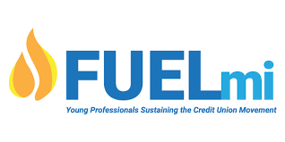
Structure:
FUELmi broken down into the 6 districts seen below.
- Each District will have its own leadership to lead their meetings
  - Director, Alternate director, treasurer/secretary
  - Members of different districts are able to attend another districts YP meeting if that meeting is closer to their location
- If unable to find leadership for certain districts, that district will be blended into neighboring district based on location
- Communication of all meetings will be sent out to all FUELmi members regardless of district.

Scheduling
- 1 in-person district meeting a quarter (Attend the districts meeting your chapter falls into)
  - All in person district meetings will have the same content for each quarterly meeting, but different deliveries based on leadership. Leadership is responsible for all content in their districts meeting.
  - Q1 - Networking, Q2 – Professional Development, Q3 - Community Involvement, Q4 - CU social mission
- 1 virtual FUELmi meeting a quarter (attended by all YPs regardless of district)
- 3 FUELmi conference meetings partnered with MCUL and CUES conferences. Scholarships to attend each conference will be available. Depending on funding, usually at least 10 scholarships per conference.
  - MCUL AC&E – June 8th – June 10th 2022
  - MCUL GAC - May 5th 2022
  - CUES - Future Summit – pending October 2022

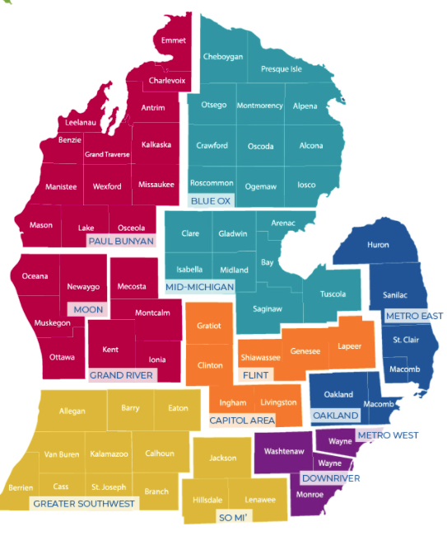
District 1 – Paul Bunyan, Moon, and Grand River Chapters
District 2 – Blue Ox and Mid-Michigan Chapters
District 3 – Flint and Capitol Area Chapters
District 4 – Metro East and Oakland Chapters
District 5 – Metro West and Downriver Chapters
District 6 – Greater Southwest and So Mi Chapters

Cost Structure
- $200 per participant
              - The more participants from same Credit Union will get discounts of $25 off each individual participating
    - 1 Participant = $200 then the next $175, $150, $125 etc..
              - $25MM CUs and under are able to send an employee for free
              - FUELmi would coup 60% of all donations, and registration costs. The other 40% would be deposited into that specific Districts account. (If there is a group formed in that district)
    - Donation allocations will be based on funds raised specifically from that chapter’s CUs.

Interested in District Leadership? Check the link below for positions available.
FUELmi District Leadership.xlsx (sharepoint.com)

