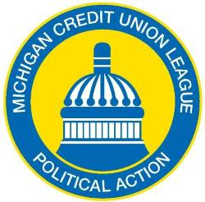
2017 LAPEL PIN PROGRAM
EMPLOYEE PAYROLL DEDUCTION AUTHORIZATION FORM

To comply with state law the MCUL State PAC is the Michigan credit union movement’s Political Action Committee (PAC) organized for the purpose of making campaign contributions to candidates for elective office in the Michigan Legislature and other statewide elective offices. Contributions to the MCUL State PAC allow us to support candidates for elected offices who recognize the importance and value of credit unions.

I authorize my employer, to deduct the amount indicated below from my net pay on a bi-weekly basis for 12 consecutive months and transmit that amount to the MCUL State PAC on my behalf until I provide written notice to suspend such contributions. These contributions to the MCUL State PAC will continue each year (and a new pin will be provided each calendar year) until I provide written notice to my employer to end my participation in the lapel pin payroll deduction program.
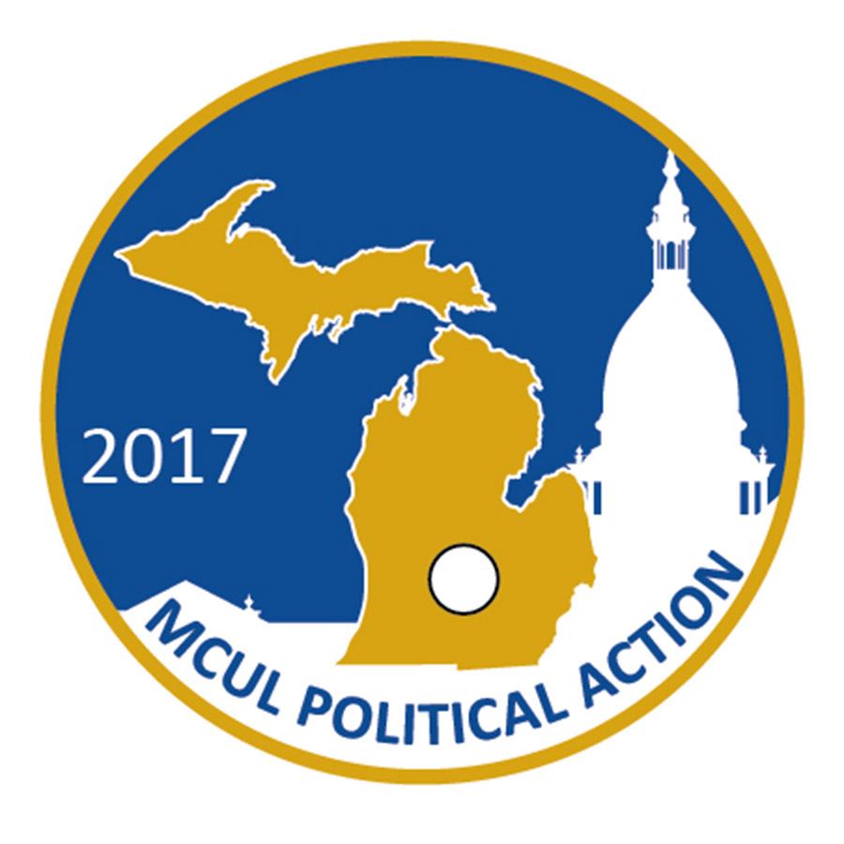
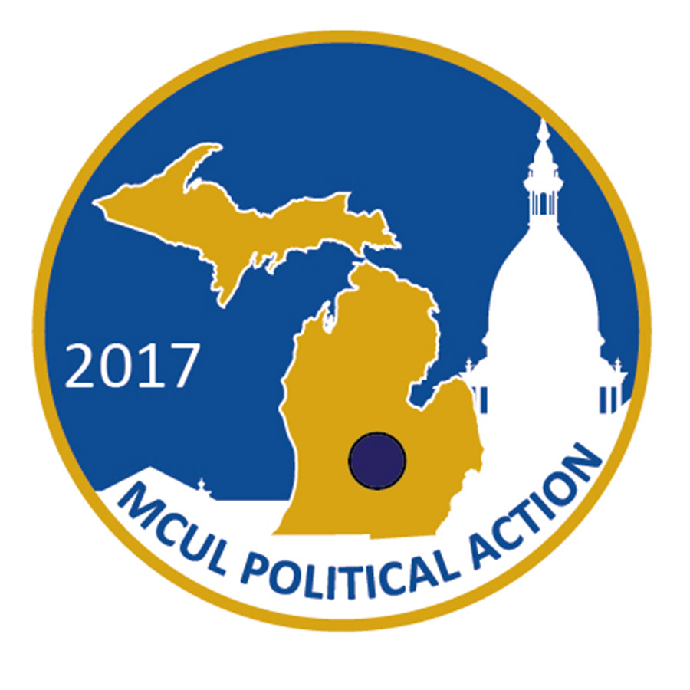
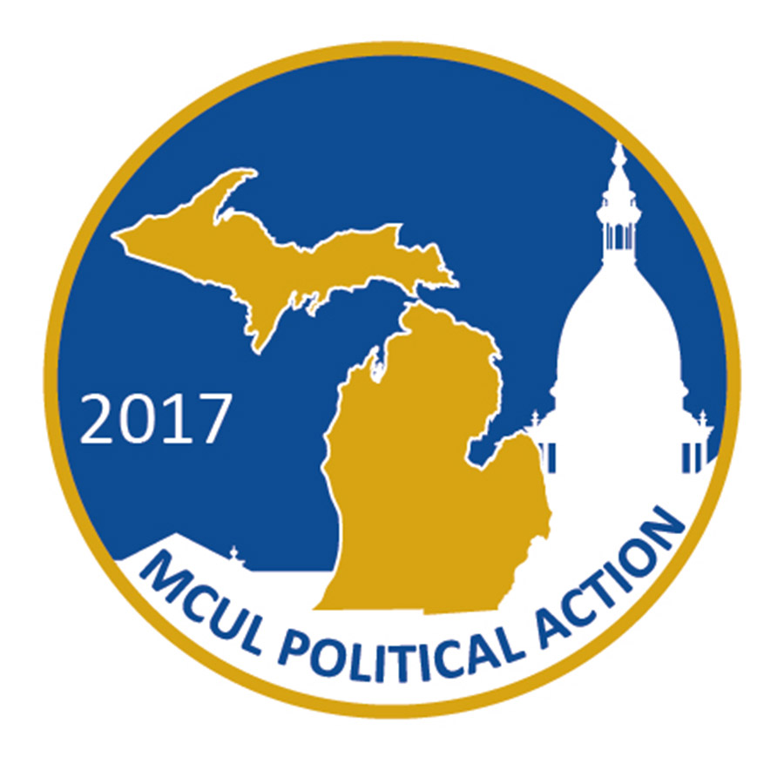
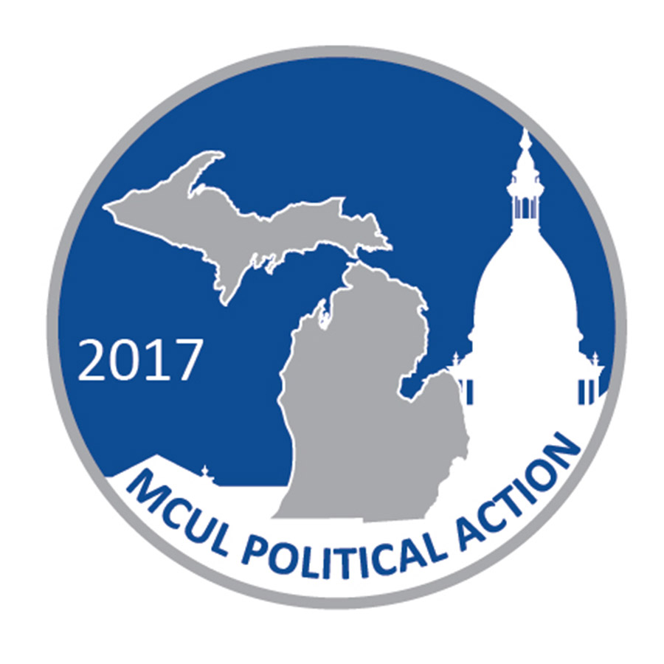
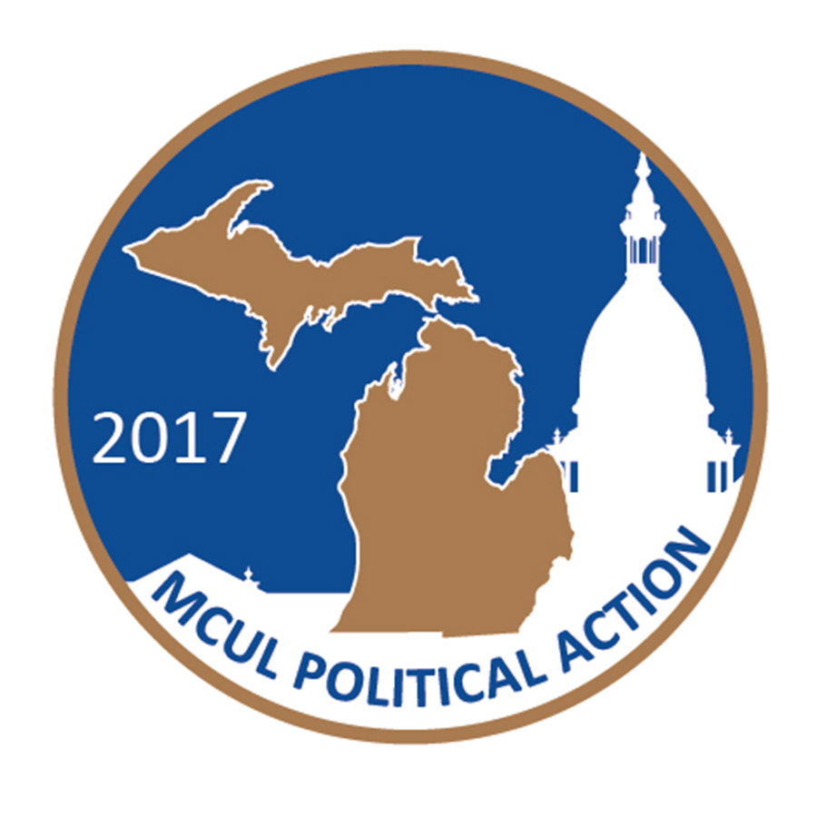
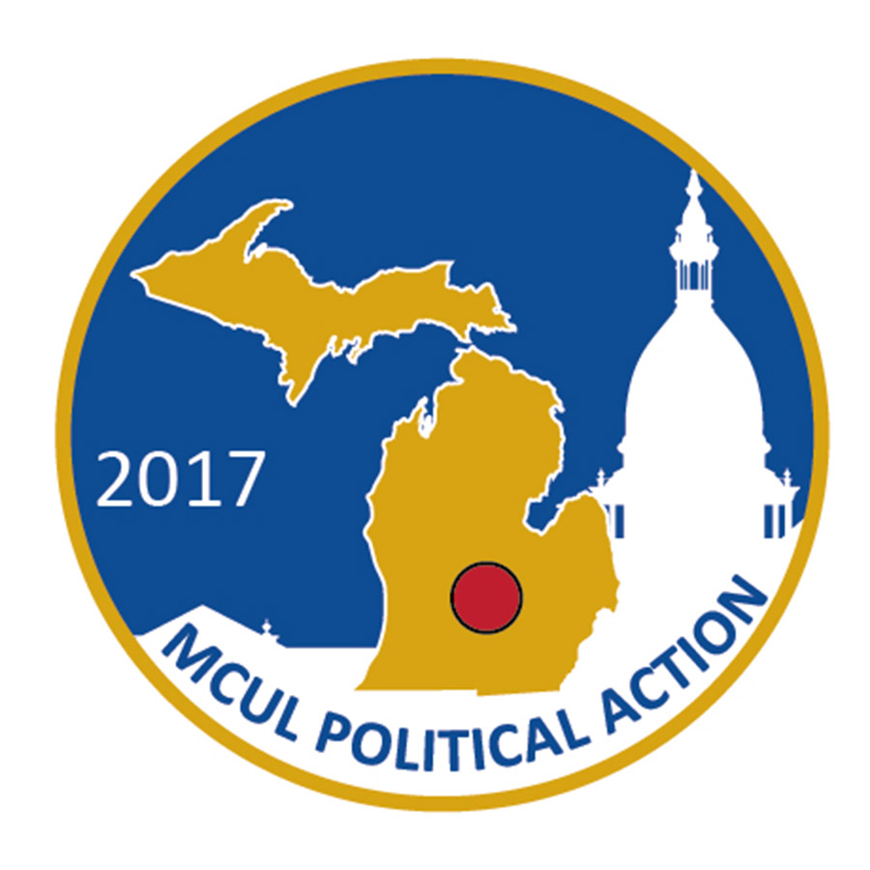
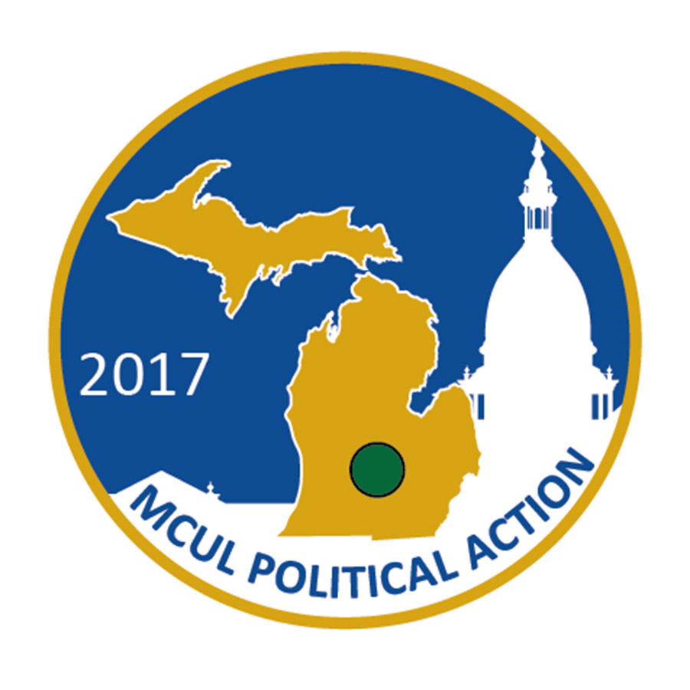
$1,500 $1,000 $500 $250 $125 $60 $30

TWELVE MONTH PLAN (based on bi-weekly pay, 26 pay periods)

_____ $1,500 ($57.69 per pay) Credit Union Champion Club (Gold with green stone)
_____ $1,000 ($38.46 per pay) Michigan Club (Gold with red stone)
_____ $500 ($19.23 per pay) Chairman’s Club (Gold with white stone)
_____ $250 ($9.62 per pay) Governor’s Club (Gold with blue stone)
_____ $125 ($4.81 per pay) Senate Club (Gold)
_____ $60 ($2.31 per pay) House of Representatives Club (Silver)
_____ $30 ($1.15 per pay) Capitol Club (Bronze)

❒ Please send me my 2017 pin  I already received my 2017 pin

Contributor Information:

Name: _________________________________________________________________________

Home Address: __________________________________________________________________

City/State/Zip: ___________________________________________________________________

Occupation: _____________________________________________________________________

Signature: __________________________________________ Date: _______________________

PLEASE RETURN COMPLETED FORM TO YOUR PAYROLL ADMINISTRATOR AND MAIL A COPY TO: MCULAF, ATTN: Haleigh Krombeen
110 W. Michigan Ave., Suite 400, LANSING, MI 48933

Affirmative Consent to Political Contribution: Section 55(6) of the Michigan Campaign Finance Act provides that a corporation, a joint stock company, a domestic dependent sovereign, or a labor organization “may solicit or obtain contributions for a separate segregated fund established on an automatic basis, including but not limited to a payroll deduction plan, only if the individual who is contributing to the fund affirmatively consents to the contribution.” Contributions to MCULAF are not tax deductible. Contributions to MCULAF are completely voluntary and will be used for political purposes. You have the right to refuse to participate without any reprisal. Note: This communication is being sent to employees who are in professional, supervisory, managerial and administrative non-clerical positions or members of MCUL-affiliated credit unions. If you are not included in any of these categories please disregard this communication.

